**School Lunch Ordering System**

Business Requirements Document (BRD) Template

Project/Initiative

04 2023

Version 1.1

# Document Revisions

|  |  |  |
| --- | --- | --- |
| Date | Version Number | Document Changes |
| 21/04/2023 | 1.0 | Initial version |
| 26/04/2023 | 1.1 | Remove link account for parent because the account linking will be added manually when school administrator send to us. |
|  |  |  |
|  |  |  |
|  |  |  |
|  |  |  |
|  |  |  |
|  |  |  |
|  |  |  |

# Approvals

|  |  |  |  |  |
| --- | --- | --- | --- | --- |
| **Role** | **Name** | **Title** | **Signature** | **Date** |
| Project Sponsor |  |  |  |  |
| Business Owner |  |  |  |  |
| Project Manager |  |  |  |  |
| System Architect |  |  |  |  |
| Development Lead |  |  |  |  |
| User Experience Lead |  |  |  |  |
| Quality Lead |  |  |  |  |
| Content Lead |  |  |  |  |

# Introduction

## Project Summary

### Objectives

* Deliver a School Lunch Ordering System (SLOS) that allows parent and student order or preorder lunchs, top up balance online via multiple payment types.
* Let parent selecting nutritious and well-balanced meals for their children, monitoring their lunch choices and spending.
* Let school managing lunch order process more efficiency and accuracy, improving food supply planning and reduce waste.

### Background

The school administration has been facing several business issues related to the school lunch program, including inefficiencies in the ordering process, inaccuracies in orders, and difficulty in managing payments. The school lunch program has also received feedback from parent and student about the need for healthier food options and greater convenience in the ordering process.

#### Business Drivers

* Operational efficiency: The current lunch ordering process was inefficient, resulting in wasted time and effort for parent and school staff. Developing a SLOS can improve operational efficiency by automating the process, reducing errors, and providing real-time tracking of orders and payments.
* Cost savings: By streamlining the lunch ordering process and reducing errors, the SLOS can help to reduce costs associated with food waste and staff time.
* Customer satisfaction: Parent and student dissatisfied with the current lunch ordering process, resulting in lower participation rates in the lunch program. Developing a user-friendly and convenient SLOS can improve customer satisfaction and increase participation rates.
* Health and wellness: The SLOS can help to promote healthy eating habits among student by providing information about nutrition and offering healthy menu options.
* Environmental sustainability: SLOS can help to reduce waste by allowing parent to order only the food that their child will eat, minimizing leftovers and reducing food waste.
* Competitive advantage: Developing a SLOS can give the school district a competitive advantage by offering a modern and convenient lunch ordering experience, which can help to attract and retain student.

## Project Scope

### In Scope Features

* User login for parent, student and school staff
* Create, view, modify, delete meal item
* Add, remove meal item for a specific day
* Online menu with meal options and prices
* Ordering and payment processing system
* Order cancellation
* Balance top up with cash, debit or credit card and online wallet
* Order tracking and confirmation system
* Customization options for dietary restrictions or allergies
* Reporting for tracking orders, revenue, and participation rates

### Out of Scope

* Integration with the school's accounting system
* Integration with the school's student information system for student & parent identification
* Integration with third-party delivery services
* Integration with external loyalty programs or rewards systems
* User feedback and rating system for meals
* Notification system for order updates and changes
* Order editing
* Inventory management and tracking for ingredients and supplies
* Automated menu rotation
* Custom mobile application development
* Personalized nutrition plans or recommendations

## System Perspective

### Assumptions

* Legal and regulatory compliance: The SLOS will comply with all relevant state laws and regulations related to food safety, online payments, and privacy.
* Technical feasibility: The development team has the necessary technical expertise to design, build, and implement the SLOS within the allotted timeline (go-live date 01/06/2023) and budget (50,000$).
* Operational feasibility: The school has the necessary resources and infrastructure in place to support the SLOS, including reliable internet access and hardware for order processing.
* Stakeholder buy-in: The project stakeholders, including school administrators, parent, and food service staff, are supportive of the SLOS and are willing to actively participate in its development and implementation.

### Constraints

* Budget and resources: because of fixed budget and go-live date, there will limit the scope of the project and require careful management of expenses and timelines.
* Technical limitations: must be developed within the technical constraints of the existing infrastructure.
* Regulatory compliance: must comply with all relevant state laws and regulations related to food safety, online payments, and privacy, which may require additional time, resources, and expertise to ensure compliance.
* User adoption: the success relies on user adoption by parent, student, school administrator, and food service staff, which may be influenced by factors such as user experience, ease of use, and perceived benefits of the system.

### Risks

* Lack of stakeholder engagement: the success of the project is heavily dependent on the involvement, cooperation and adoption of the parent, student, school administration, and food service staff. If stakeholders are not fully engaged or are resistant to change, it may lead to delays, misunderstandings, and reduced support for the project.
* Inaccurate menu information: the accuracy and timeliness of menu information are critical to the success of the system. If there are inaccuracies or delays in updating the menu, it may lead to wrong orders, delayed delivery, or unhappy customers.
* Budget overruns: the project may incur unexpected costs due to unforeseen technical challenges, regulatory compliance, or stakeholder demands. Failure to manage these costs effectively could result in budget overruns and delays in project delivery.
* Low user adoption: The success of the SLOS depends on user adoption by parent and food service staff. If the system is difficult to use, slow, or does not provide enough benefits, it may result in low user adoption rates and reduced participation in the school lunch program.

# Business Process Overview

## Current Business Process (As-Is)

The school currently does not have an ordering system; student must come to the canteen at lunchtime to select and pay for their meals with cash or card. The school canteen currently has a meals schedule tracked on an Excel spreadsheet and is managed manually. Parent and student are not aware of the types of food served on any given day, the ingredients, etc. due to the lack of an ordering system, and preordering for lunch is not available. Additionally, parent are unable to monitor their children's orders. As a result, the school has a lot of wasted food and difficulty in preparing their food supply as they cannot predict which meals student would like for lunch.

## Proposed Business Process (To-Be)

The School Lunch Ordering System (SLOS) will be a web platform that enables parent, student, school administrators, and food service staff to log in to the system. The school administrators will be able to select a day on the calendar and create lunch menus for that day, including details such as price, ingredients, dietary restrictions, allergies, and quantities for each type of food.

Parent and student will be able to log in, top up the student account balances using bank cards, online wallets, or by requesting manual top-up by the school administrator if they wish to pay by cash. They can then select a day on the calendar, filter food options, and place their orders. The system will confirm the order if the balance is sufficient to cover the total amount.

Before the day of the order, the orders can be canceled, and the balance will be added back to the account. Since the ordered day, the orders cannot be canceled. The system will generate an order code automatically, which the student will bring to the canteen at lunchtime. The food service staffs will log in to the website, scan the code or input it manually, give the food to the student and mark the order as finished.

The SLOS will also include role-specific reports that the parent, student, and school administrators can access to view information relevant to their respective roles.

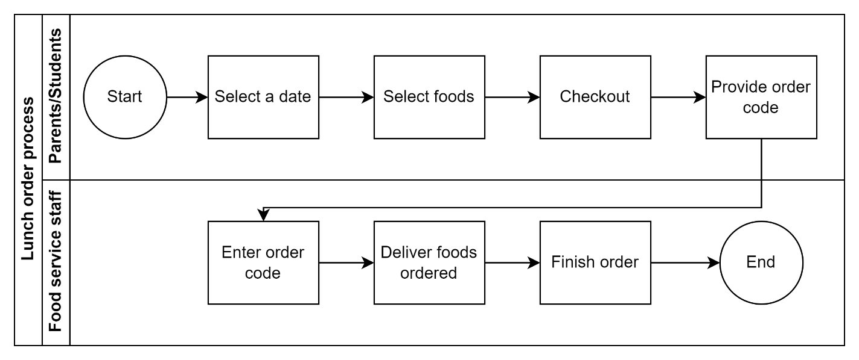

# Appendices

## List of Acronyms

[If needed, create a list of acronyms used throughout the BRD document to aid in comprehension.]

* SLOS: School Lunch Ordering System
* BRD: Business Requirements Document

## Glossary of Terms

[If needed, identify and define any terms that may be unfamiliar to readers, including terms that are unique to the organization, the technology to be employed, or the standards in use.]

* Administrator: A school staff who responsible for managing the SLOS, creating menus, managing user accounts, and generating reports.
* Student: A person enrolled in the school and able to order meals through the SLOS.
* Parent: a person who is legally responsible for a student attending the school and is authorized to manage their lunch orders via the School Lunch Ordering System (SLOS).
* Food Service Staff: the personnel responsible for preparing, cooking, and serving food in the school canteen, who are authorized to access the SLOS to fulfill student lunch orders.
* Canteen: A cafeteria or dining hall where students can buy food.
* Dietary Restrictions: A set of restrictions on what types of food can be consumed due to medical or religious reasons.
* Order Code: A unique code generated by the SLOS for each confirmed order.
* Quantity: The number of servings available for each type of food on a given day.
* User: A person who interacts with the SLOS, including students, parents, food service staffs and administrators.
* Balance: Refers to the amount of money that a student has in their lunch account to purchase meals through the SLOS.

## Related Documents

[Provide a list of documents or web pages, including links, which are referenced in the BRD.]